Introduction of the project
The project is to work with mongodb and neo4j to design data schema for a Question and Answer data set respectively to answer a list of target queries respectively which include very basic OLTP type queries and
analytic queries.
MongoDB– Schema Design
In the final schema, there is only one collection in the database,wherein, each document represents one question and its related information.
The collection fields are illustrated as below
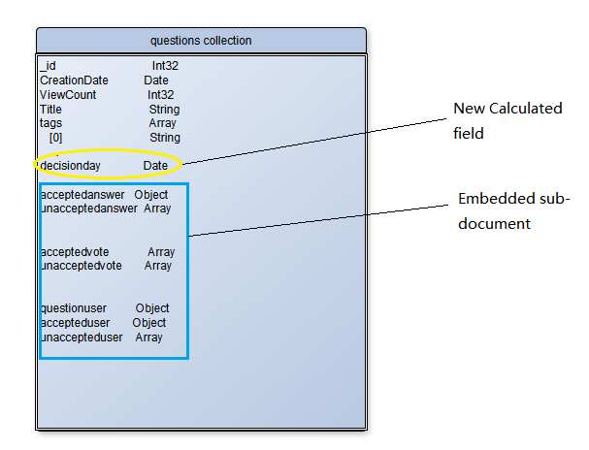
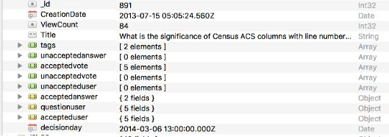
Figure 1 mongodb collection fields

The primary key is the _id, which represents the Question’s Id;
CreationDate, ViewCount, Title are the question’s CreationDate, ViewCount and Title;
tags is an array field, each element in the array represents a tag attached to the question;
acceptedanswer is the question’s accepted answer, it is an object containing two fields: Id,CreationDate which represents the question’s accepted answer’s Id and CreationDate respectively;
unacceptedanswer is the question’s unaccepted answers, it is an array, each element is an object containing three fields: Id, CreationDate and OwnerUserId which represents the question’s unaccepted answer’s Id, CreationDate and OwnerUserId respectively;
acceptedvote is the question’s accepted answer’s vote, it is an array , each element containing two fields: VoteTypeId and CreationDate which represents the question’s accepted answer’s vote’s VoteTypeId and CreationDate respectively;
unacceptedvote is the question’s unaccepted answer’s vote, it is an array ,each element containing two fields: VoteTypeId and CreationDate which represents the question’s unaccepted answer’s vote’s VoteTypeId and CreationDate respectively;
questionuser is the question’s owner-user, it is an object, containing five fields:Id,CreationDate,DisplayName,UpVotes,DownVotes, which represents the question’s user’s Id,CreationDate,DisplayName,UpVotes,DownVotes respectively;

accepteduser is the question’s accepted answer’s owner-user, it is an object, containing five fields:Id,CreationDate,DisplayName,UpVotes,DownVotes, which represents the question’s accepted answer’ user’s Id,CreationDate,DisplayName,UpVotes,DownVotes respectively;
unaccepteduser is the question’s unaccepted answer’s owner-user, it is an array, each element containing five fields:Id,CreationDate,DisplayName,UpVotes,DownVotes, which represents the question’s unaccepted answer’ user’s Id,CreationDate,DisplayName,UpVotes,DownVotes respectively;
decisionday is the time that the question’s accepted answer is accepted.

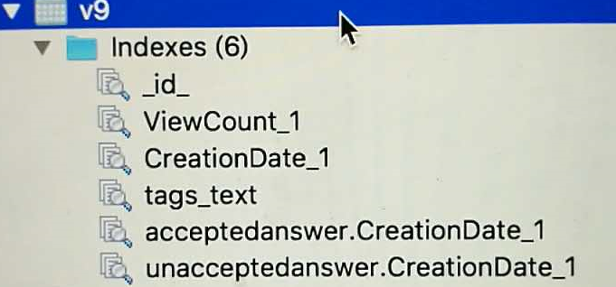
Figure 2 mongodb collection indexes

The indexes are illustrated as figure 2, there are indexes on ViewCount, CreationDate and tags, acceptedanswer.CreationDate, unacceptedanswer.CreationDate, wherein, the index on tags is “text” type.

Sample data:
{
"_id" : 4744,
"CreationDate" : ISODate("2015-03-14T16:59:42.270Z"),
"ViewCount" : 79,
"Title" : "Global map of protected areas by IUCN category",
"tags" : [
"data-request",
"maps",
"environment"
],
"unacceptedanswer" : [
{
"Id" : 4780,
"CreationDate" : ISODate("2015-03-18T05:28:07.913Z"),
"OwnerUserId" : 1667
},
{
"Id" : 7346,
"CreationDate" : ISODate("2016-03-16T11:18:10.113Z"),
"OwnerUserId" : 10618
}
],
"acceptedvote" : [
{
"VoteTypeId" : 2,
"CreationDate" : ISODate("2015-07-11T14:00:00.000Z")
},
{
"VoteTypeId" : 1,
"CreationDate" : ISODate("2017-04-30T14:00:00.000Z")
}
],
"unacceptedvote" : [
{
"VoteTypeId" : 2,
"CreationDate" : ISODate("2016-06-02T14:00:00.000Z")
},
{
"VoteTypeId" : 2,
"CreationDate" : ISODate("2016-06-02T14:00:00.000Z")
},
{
"VoteTypeId" : 2,
"CreationDate" : ISODate("2015-07-11T14:00:00.000Z")
},
{
"VoteTypeId" : 2,
"CreationDate" : ISODate("2017-05-02T14:00:00.000Z")
}
],
"unaccepteduser" : [
{
"Id" : 1667,
"CreationDate" : "2013-12-22T18:01:55.787",
"DisplayName" : "Andrew - OpenGeoCode",
"UpVotes" : 22,
"DownVotes" : 1
},
{
"Id" : 10618,
"CreationDate" : "2016-03-16T16:39:01.787",
"DisplayName" : "jmass22",
"UpVotes" : 0,
"DownVotes" : 0
}
],
"acceptedanswer" : {
"Id" : 6605,
"CreationDate" : ISODate("2015-12-06T13:28:09.293Z")
},
"questionuser" : {
"Id" : 190,
"CreationDate" : "2013-05-09T02:43:02.637",
"DisplayName" : "gerrit",
"UpVotes" : 85,
"DownVotes" : 0
},
"accepteduser" : {
"Id" : 190,
"CreationDate" : "2013-05-09T02:43:02.637",
"DisplayName" : "gerrit",
"UpVotes" : 85,
"DownVotes" : 0
},
"decisionday" : ISODate("2017-04-30T14:00:00.000Z")
}

Design process:
tags field is preprocessing in the Excel, the"" is removed and is transformed to an array in mongodb using $split "," . And all the CreationDate is processed to Date type.
Some fields are not used by the Target Queries. For example, Score, LastEditorUserId, LastEditDate, LastActivityDate, AnswerCount,CommentCount and FavoriteCount in the posts collection imported from Posts.csv, and Reputation, LastAccessDate, Location, Vies AccountId and Age in the users collection imported from Users.csv and UserId, BountyAmount in the votes collection imported from Votes.csv. And the tags collection imported from Tags.csv is not used.
In the posts collection, some fields are only used by question, and some fields are only used by answer. Therefore, it is reasonable to extract questions and answers from the posts collection using the PostTypeId field and delete useless fields from each collection. More specifically, when the PostTypeId is 1, it is a question, and so when the questions collection is obtained, the PostTypeId is not needed anymore, and ParentId is only for an answer, so this field is also not needed anymore;when the PostTypeId is 2, it is an answer, and so when the answers collection is obtained, the PostTypeId is not needed, and AcceptedAnswerId, Title, Tags which only for questions are not needed.
Then using AcceptedAnswerId in the questions collection and Id in the answers collection to join the two collection to get the acceptedanswer field in the questions collection. And using ParentId in the answers collection and Id in the questions collection to join the two collection to get answers field in the questions collection, then uing UnionDifference to answers field and accepteanswer field to get unacceptedanswer field in the questions collection.
Then using PostId field in the Votes collection and acceptedanswer.Id field in the questions collection to join the two collections to get acceptedvote field in the questions collection. Then using PostId field in the Votes collection and unacceptedanswer.Id field in the questions collection to join the two collections to get unacceptedvote field in the questions collection.
Then using Id field in the users collection and OwnerUserId field in the questions collection to join the two collections to get questionuser field in the questions collection.
Then using Id field in the users collection and acceptedanswer.OwnerUserId field in the questions collection to join the two collections to get accepteduser field in the questions collection.
Then using Id field in the users collection and unacceptedanswer.OwnerUserId field in the questions collection to join the two collections to get unaccepteduser field in the questions collection.
decisionday is calculated for each question : when acceptedvote.VoteTypeId is 1, take the acceptedvote.CreationDate as decisionday.
And in the above process steps, there are some join fields are duplicated, so duplicated Ids such as questionuser.Id and OwnerUserId are not in the final schema(not $project) and some Ids are useless suchas Vote.Id, so they are not projected to the final schema.
And when joining two collections, the joining field is an array, but questionuser, accepteduser, acceptedanswer is logically only one, so unwind them to an object field in the questions collection.

MongoDB Query Design and Execution
Simple queries
1. Find all users involved in a given question (identified by id) and their respective profiles including the creationDate, DisplayName, upVote and DownVote.
shell query command and its result
db.getCollection('v9').aggregate([
{$match:{_id:891}},
{$project:{users:{$setUnion:[new Array("$questionuser"),new Array("$accepteduser"),"$unaccepteduser"]}}}
])
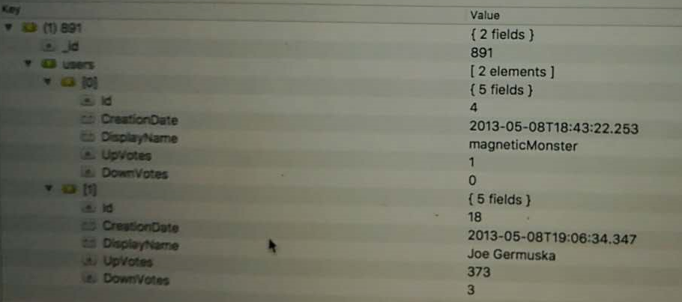
performance analysis: Because there is a default index on _id field which is the question’s id, so the match stage in the pipeline is very fast, and the project stage is just do some setUnion and project to new field in the memory, so this query can be run very fast.
- Assuming each tag represents a topic, find the most viewed question in a certain topic.
shell query command and its result
db.getCollection('v9').aggregate([
{$unwind:"$tags"},
{$match:{tags:"address"}},
{$sort:{"ViewCount":-1}},
{$limit:1}
])
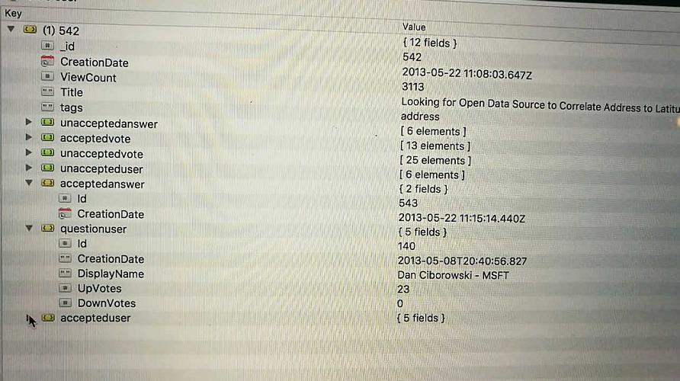
performance analysis: there are indexes on tags and ViewCount, the query may use the indexes, unwind and limit stage is just some operations in the memory, so the query can be very fast.
Analytic queries
- We want to discover the questions that are easy to answer. We measure easiness with the time it took to receive an accepted answer. The shorter the time, the easier the question. Given a list of topics, you are asked to list the question easiest to answer in each topic.
shell query command and its result
db.getCollection('v9').aggregate([
{$unwind:"$tags"},
{$match:{tags:"usa"}},
{$unwind:"$acceptedanswer"},
{$project:{tags:1,Title:1,easy:{$subtract:["$acceptedanswer.CreationDate", "$CreationDate"]}}},
{$sort:{"easy":1}},
{$limit:1}
])
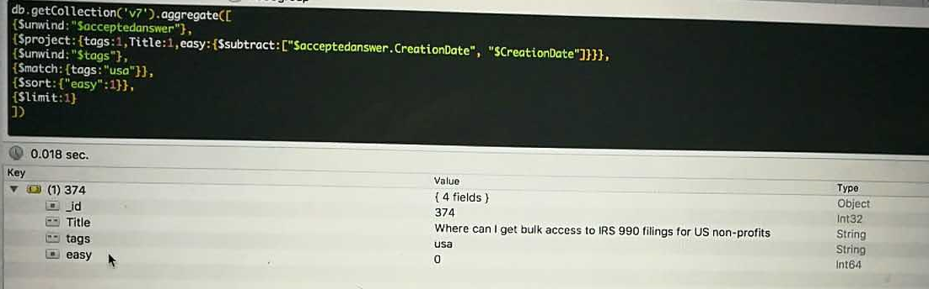
performance analysis: the index on tag field may be used, after match specific tag, then the documents will be much smaller. There are some calculations for the time differences between question’s creation date and accepted answer’s creation date in the memory, and sort stage will also take some time to process in the memory too.
- We are interested in discovering trending topics in a certain period. An indicator of trending could be the number of users who have participated in the discussion, by posting either questions or answers, during the period. You are asked to list five such hottest topics in a given period as well as the number of users in each.
shell query command and its result
db.getCollection('v9').aggregate([
{$project:{tags:1,"question":{CreationDate:"$CreationDate", userid:"$questionuser.Id"},
acceptedanswer:{CreationDate:"$acceptedanswer.CreationDate", userid:"$accepteduser.Id"},
"unacceptedanswer.CreationDate":1, "unacceptedanswer.OwnerUserId":1}},
{$project:{_id:1,tags:1,users:{$setUnion:["$unacceptedanswer", new Array("$acceptedanswer"),new Array("$question")]}}},
{$unwind:"$tags"},
{$unwind:"$users"},
{$match:{"users.CreationDate":{$gt: new Date("2013-07-15"),$lt:new Date("2013-07-20")}}},
{$group:{_id:"$tags", count:{$sum:1}}},
{$sort:{"count":-1}},
{$limit:5}
])
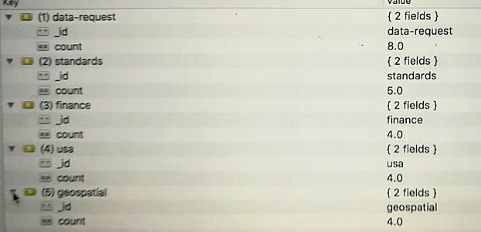
performance analysis: Firstly, there are some project operations and unwind operations in the memory, and there are indexes on question.CreationDate , acceptedanswer.CreationDate, unacceptedanswer.CreationDate, so the match stage will be faster, and the group and sort stage will be processed in the memory and take some time and space.
- We are also interested in discovering champion user in a certain topic. A champion user has the most answers accepted in that topic. Given a topic, you are asked to list the champion user and all questions the user has answers accepted in that topic.
shell query command and its result
db.getCollection('v9').aggregate([
{$unwind:"$tags"},
{$match:{tags:"usa"}},
{$group:{_id:"$accepteduser.Id",count:{$sum:1},questions:{$addToSet:"$Title"}}},
{$match:{_id:{$ne:null}}},
{$sort:{"count":-1}},
{$limit:1}
])
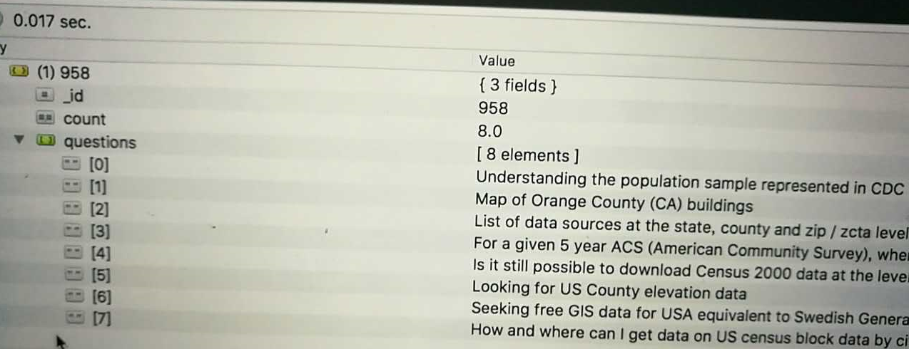
performance analysis: There is an index on the tags field, so match a certain topic is faster, and the documents transferred to next stage is much smaller, the group and sort stage will be processed in the memory and will take some time and space.
6. Some questions may not have accepted answers. They are considered as unanswered questions. We would like to recommend those questions to a group of potential answerer. For any active user, if the user has n answers accepted in a certain topic and n is greater than or equal to a threshold value α, we consider the user a potential answerer of unanswered questions in that topic. You are asked to recommend up to
5 most recent unanswered questions to a given user.
Solution thinking: first find the given user’s topics, then get these topics’s unanswered questions, and then sort them by CreationDate, find the 5 most recent ones.
shell query command and its result
db.getCollection('v9').aggregate([
{$match:{"accepteduser.Id":35}},
{$unwind:"$tags"},
{$group:{_id:"$tags", questions:{$addToSet:"$_id"},count:{$sum:1}}},
{$match:{count:{$gte:1}}},
{$project:{topic:"$_id"}},
{$group:{_id:null, topics:{$addToSet:"$topic"}}},
{$project:{_id:"$topics"}},
{$unwind:"$_id"},
{$lookup:{
from:"v9",
localField:"_id",
foreignField:"tags",
as:"god"
}},
{$project:{questions:"$god"}},
{$unwind:"$questions"},
{$project:{questions:1,_id:0}},
{$project:{_id:"$questions._id",CreationDate:"$questions.CreationDate", ViewCount:"$questions.ViewCount",Title:"$questions.Title",tags:"$questions.tags",
unacceptedanswer:"$questions.unacceptedanswer",acceptedvote:"$questions.acceptedvote",unacceptedvote:"$questions.unacceptedvote",
unaccepteduser:"$questions.unaccepteduser",acceptedanswer:"$questions.acceptedanswer",questionuser:"$questions.questionuser",accepteduser:"$questions.accepteduser",
decisionday:"$questions.decisionday"}},
{$match:{acceptedanswer:null}},
{$project:{_id:{id:"$_id",creationdate:"$CreationDate"},id:"$_id", creationdate:"$CreationDate"}},
{$group:{_id:"$_id"}},
{$project:{_id:"$_id.id",creationdate:"$_id.creationdate"}},
{$sort:{CreationDate:-1}},
{$limit:5}
])
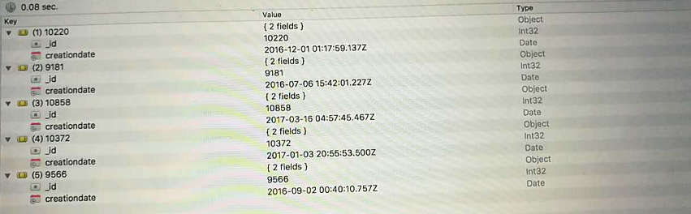

performance analysis: the query may use the index on the CreationDate. After find the user’s topics, there is a lookup stage, it will take some time and space in the memory, and unwind ,project, sort ,limit stages will be processed in the memory.
- We want to know if the acceptance of an answer would affect its upVote as well as other answers’ upVote. We denote the day an answer is accepted as “decision day”. You are asked to find out among all questions whose total number of upVote is greater than or equal to a certain threshold value α :
– The question whose accepted answer has the highest percentage of upVote received after the “decision day”
shell query command and its result
db.getCollection('v9').aggregate([
{$project:{votes:{$concatArrays:["$acceptedvote","$unacceptedvote"]}}},
{$unwind:"$votes"},
{$match:{"votes.VoteTypeId":2}},
{$group:{_id:"$_id",count:{$sum:1}}},
{$match:{count:{$gte:10}}},
{$lookup:{
from:"v9",
localField:"_id",
foreignField:"_id",
as :"questions"
}},
{$unwind:"$questions"},
{$project:{_id:"$questions._id",CreationDate:"$questions.CreationDate", ViewCount:"$questions.ViewCount",Title:"$questions.Title",tags:"$questions.tags",
unacceptedanswer:"$questions.unacceptedanswer",acceptedvote:"$questions.acceptedvote",unacceptedvote:"$questions.unacceptedvote",
unaccepteduser:"$questions.unaccepteduser",acceptedanswer:"$questions.acceptedanswer",questionuser:"$questions.questionuser",accepteduser:"$questions.accepteduser",
decisionday:"$questions.decisionday"}},
{$project:{tags:1,acceptedvote:1,decisionday:1,total:{$size:"$acceptedvote"}}},
{$unwind:"$acceptedvote"},
{$match:{"acceptedvote.VoteTypeId":2}},
{$project:{difference:{$subtract:["$acceptedvote.CreationDate","$decisionday"]},tags:1,acceptedvote:1,total:1}},

{$match:{difference:{$gt:0}}},
{$group:{_id:"$_id",tags:{$addToSet:"$tags"},total:{$addToSet:"$total"},amount:{$sum:1}}},
{$project:{amount:1,total:{$arrayElemAt:["$total",0]},tags:{$arrayElemAt:["$tags",0]}}},
{$project:{tags:1, percentage:{$divide:["$amount","$total"]}}},
{$sort:{"percentage":-1}},
{$limit:1}
])
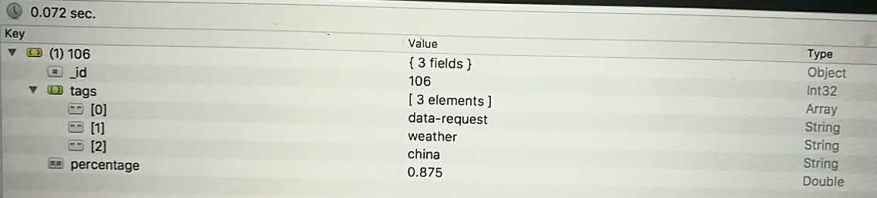

– The question whose other answers as a whole has the highest percentage of upVote received after the “decision day”.
shell query command and its result
db.getCollection('v9').aggregate([
{$project:{votes:{$concatArrays:["$acceptedvote","$unacceptedvote"]}}},
{$unwind:"$votes"},
{$match:{"votes.VoteTypeId":2}},
{$group:{_id:"$_id",count:{$sum:1}}},
{$match:{count:{$gte:10}}},
{$lookup:{
from:"v9",
localField:"_id",
foreignField:"_id",
as :"questions"
}},
{$unwind:"$questions"},
{$project:{_id:"$questions._id",CreationDate:"$questions.CreationDate", ViewCount:"$questions.ViewCount",Title:"$questions.Title",tags:"$questions.tags",
unacceptedanswer:"$questions.unacceptedanswer",acceptedvote:"$questions.acceptedvote",unacceptedvote:"$questions.unacceptedvote",
unaccepteduser:"$questions.unaccepteduser",acceptedanswer:"$questions.acceptedanswer",questionuser:"$questions.questionuser",accepteduser:"$questions.accepteduser",
decisionday:"$questions.decisionday"}},
{$project:{tags:1,unacceptedvote:1,decisionday:1,total:{$size:"$unacceptedvote"}}},
{$unwind:"$unacceptedvote"},
{$match:{"unacceptedvote.VoteTypeId":2}},
{$project:{difference:{$subtract:["$unacceptedvote.CreationDate","$decisionday"]},tags:1,unacceptedvote:1,total:1}},

{$match:{difference:{$gt:0}}},
{$group:{_id:"$_id",tags:{$addToSet:"$tags"},total:{$addToSet:"$total"},amount:{$sum:1}}},
{$project:{amount:1,total:{$arrayElemAt:["$total",0]},tags:{$arrayElemAt:["$tags",0]}}},
{$project:{tags:1, percentage:{$divide:["$amount","$total"]}}},
{$sort:{"percentage":-1}},
{$limit:1}
])
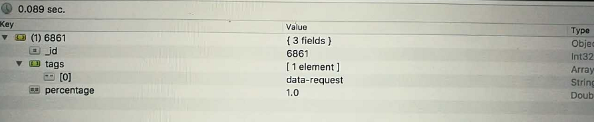

performance analysis: There is a lookup stage, it will take some time and space in the memory. There is no index that can be used. The project, group, unwind, sort and limit stages will be processed in the memory. In the processing ,there are some calculations which will take time and space in the memory.
- Consider all users involved in a question as co-authors, for a given user, find out this user’s top 5 co-authors based on the number of times they appear in the same question either as originator or answerer.
shell query command and its result
db.getCollection('v9').aggregate([
{$project:{questionuser:"$questionuser.Id",accepteduser:"$accepteduser.Id", unaccepteduser:"$unaccepteduser.Id"}},
{$project:{users:{$setUnion:[new Array("$questionuser"),new Array("$accepteduser"),"$unaccepteduser"]}}},
{$match:{users:18}},
{$unwind:"$users"},
{$match:{users:{$ne:18}}},
{$group:{_id:"$users",count:{$sum:1}}},
{$sort:{"count":-1}},
{$match:{_id:{$ne:null}}},
{$limit:5}
])
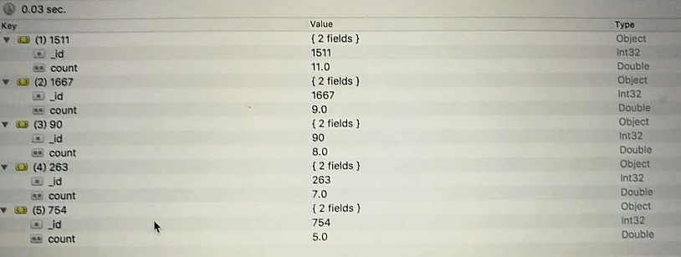
performance analysis: firstly using a match to reduce the documents transferred to next stage. There is no index to use in this query. The project, setUnion, and group, sum, sort and compare will be processed in the memory and will take some time and space.

Comparison of MongoDB and Neo4j
In terms of ease of use, for mongodb, the interface of third party client side tool, Robomongo, is a great tool and make it much easier to type in command and to view the results. But import and export data can only be done through command line window. While for neo4j, it is a little messy of the interface, different database’s node, edge, property are mixed together. And when you run a lot of queries and forget to close them, the system will get slower and slower and you even cannot see your typed words in the query input area immediately.
In terms of query performance, for the same amount of data, mongodb can process faster than neo4j. And when the query command is wrong
the messages given by mongodb is much more detail and clear, the neo4j can only give a general information.
In terms of schema differences, in mongodb, the a relationship between entities can be expressed as an embedded sub-document, or as a reference using a local field, and you need to use dot or $lookup to get another entity’s fields. But in neo4j, usually match entity-relationship-entity, and the entity’s property and relationship’s property can easily be used at the same time.
Problems with mongodb, when you use group stage to get some fields’ values, and if you want to use these values to do further queries, you have to $lookup the original collection, it is time-consuming and the query is very long in this case.
Problems with neo4j, the order by operation cannot be used after “union” multiple “match”, “return”, you have to use “with collect” and “unwind “to replace the “union”，it is inconvenient to use.

